**Mini Project Report**

**on**

**Software for Library Management system**

**(CSE-CE III Semester)**

2021-2022

**Submitted to: Submitted by:**

Dr. Narayan Chaturvedi Yogendra Bharadwaj

Dr. Jyoti Agarwal Roll. No.: 2017787

CSE-CE-III-Sem

Session: 2021-2022

**DEPARTMENT OF COMPUTER SCIENCE AND ENGINEERING**

**GRAPHIC ERA (DEEMED TO BE) UNIVERSITY, DEHRADUN**



**REPORT**

**TABLE OF CONTENTS Page No.**

1. ABSTRACT 3
2. PROJECT INTRODUCTION AND GOAL 4
3. SCREENSHOTS 5
4. CONCLUSION 13
5. REFERENCES 14



The library contains thousands of books and records of members that must be organized in order to prevent chaos. As our technology improves, we try to reduce the manual paperwork by using computers. Therefore, the simple solution to reduce the paperwork is to computerize the whole library system.

1. **PROJECT INTRODUCTION AND OBJECTIVE**



Library Maintenance Software is a Software which is widely used in school, college libraries, which provide all the functions of a library including creating records to book, issue and deposit.

Using this software, schools and colleges can reduce their time for their library services and all the library work will be done seamlessly. All the paperwork will be reduced by use of this software.



This software is to create a library maintenance system to maintain the library by keeping book records in an arranged manner. The functions include addition/deletion of books, addition/deletion of students, display of specific students and specific books, etc. The software keeps a basic security level by using OOPS concepts that do not allow the user to modify the code and protect it.



The main objective of this C++ project is to maintain the library by managing the details of books, students, issues and deposits. It manages all the details in a proper fashion. In this software, the admin is granted the access to create and delete the record. This software reduces the paperwork for maintaining the library. It keeps track of all details about students’ books and which student issued which book and etc.



**1. **

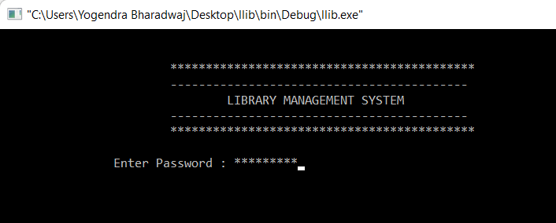

**AS WE ALL KNOW OUR HOME SCREEN AND MAIN SCREEN IS 1ST IMPRESSION OF ANY PROJECT OF SOFTWARE AND APPLICATION, RELATED SERVICE.**

DURING MY INITIAL STAGE (BEFORE START WORKING ON THIS PROJECT) I SAW MANY OF APPLICATION

WHICH IS RELATED TO THIS, THEY JUST ONLY LOCK ADMINISTRATIVE SECTION, BUT ACCORDING TO ME WE SHOULD LOCK INITIALLY BECAUSE NO LOOPHOLES IS LEFT, SO THAT NO ONE CAN DO ANY UNETHICAL ACTIVITY OR WE CAN SAY NO LOOPHOLES IS LEFT .

**2.**

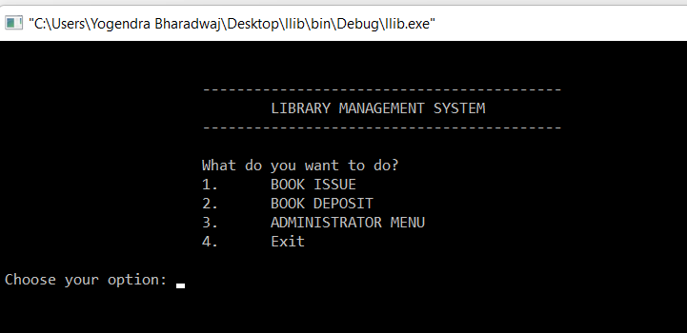

IN PREVIOUS SECTION (HOME SCREEN) I ALREADY SAID  **AS WE ALL KNOW HOME SCREEN AND MAIN SCREEN IS 1ST IMPRESSION OF OUR PROJECT IN THE FIELD OF SOFTWARE WEB AND APPLICATION RELATED SERVICE.**

**SO, AFTER CLEARING SECURITY YOU DIRECT COME IN MAIN PAGE WHERE 4 OPTION ARE GIVEN.**

**HERE WE INITIALLY WE SEE 4TH OPTION ADMINISTRATOR MENU BECAUSE 1ST WE HAVE TO CREATE STUDENT RECORD AND BOOK RECORD WHICH IS ONLY POSSIBLE IN 4TH OPTION ADMINISTRATOR MENU THAN WE CAN ISSUE AND DEPOSIT BOOK ONLY.**

**1**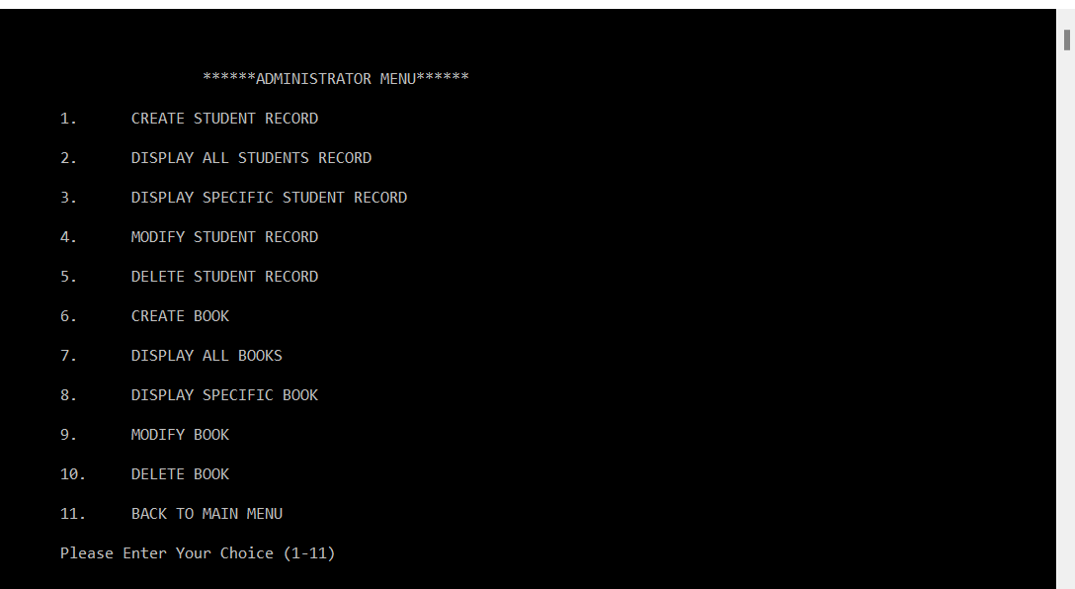

IN ADMINISTRATOR MENU TOTAL 10 MAIN MENU AND 1 (I.E) 11MENU IS FOR GO BACK FOR MAIN MENU .

(HERE WE SEE ALL ONE BY ONE)

1. 

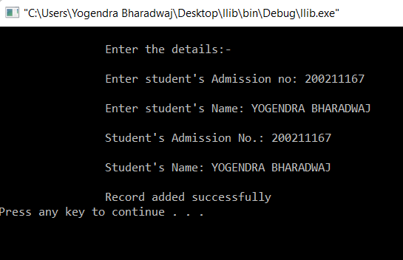

**HERE 1ST WE HAVE TO CREATE ALL STUDENT RECORD WHICH IS STUDY IN THAT INSTITUTION WHERE THIS IS USED FOR THAT THEY HAVE ADMISSION NO .IS MUST AFTER THAT STUDENT NAME**

AFTER FILL THE INFORMATION SOFTWARE SHOW CONFORMATION THAT IS RECORD ADD **SUCCESSFULLY**

**2.**

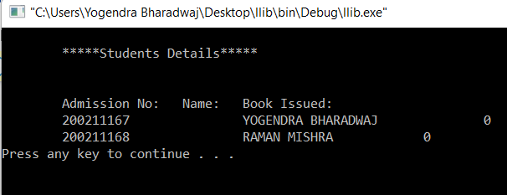

HERE WITH THIS OPTION, WE CAN SEE ALL THE STUDENT LIST WHICH IS ELIGIBLE FOR ISSUING BOOK

WITH THEIR NAMES AND ADMISSION NO.

HERE 1 ALSO MOST IMPORTANT RECORD IS SHOW THAT PARTICULAR STUDENT IS HOW MANY BOOK ISSUE CURRENTLY ALONG WITH THEIR NAME AND ADMISSION NO.

3.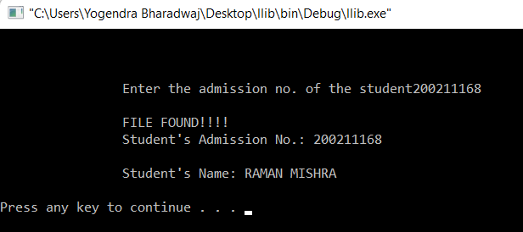

WITH THE HELP OF THIS OPTION, WE CAN DIRECTLY SEARCH THE RECORD OF PARTICULAR STUDENT WITH THE HELP OF JUST ADMISSION NO. SO WE CAN PREVENT TYME TO SEARCH IN CASE OF LONG LIST OF STUDENTS.

**4.**

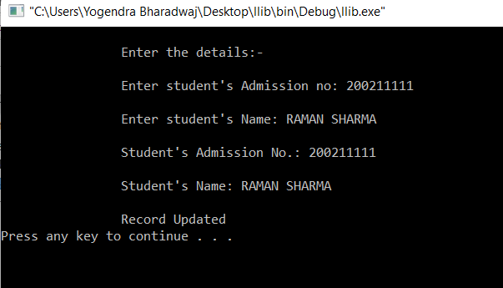

AS WE ALL KNOW LIBRARY IS SOMETIME VERY CROUDY DURING EXAM TIMES AND OTHER SOME TIME AT

THAT TIME DOING MISTAKE IS COMMON THINGS SO TO PREVENT THIS PROBLEM THIS OPTION IS INTRODUCE SO

THAT LIBRARYAN CAN MODIFY STUDENT RECORD LATER.

**5.**

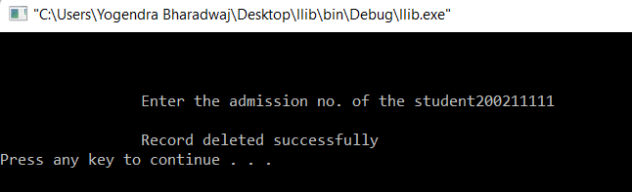

SUPPOSE STUDENTS LEFT COLLEGE AFTER COMPLETE STUDY COURSE AFTER THAT THE DELETE OF THAT STUDENT RECORD THAT’S WHY THIS OPTION IS GIVEN SO OUR SYSTEM IS OCCUPY LESS MEMORY

**6.**

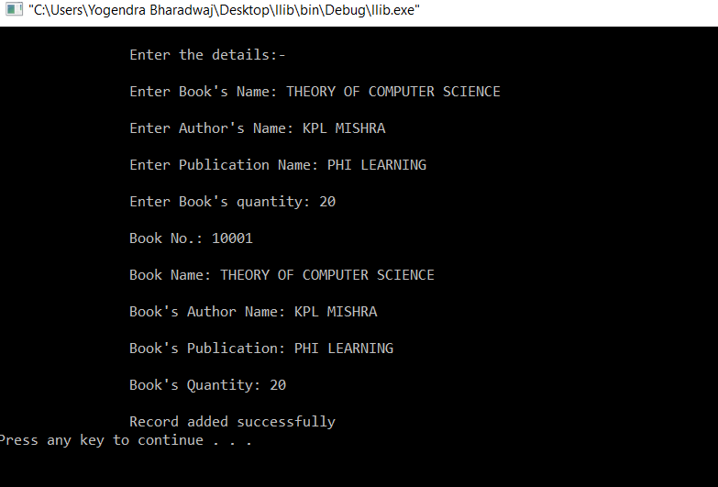

HERE WE HAVE TO CREATE RECORD OF ALL BOOK WHICH IS AVAILABLE IN LIBRARY FOR ISSUE BOOK SO THAT WE CAN KAAP RECORD,

HERE, WE HAVE TO GIVE FIRST BOOK NAME THAN AUTHOR NAME THAN PUBLICATION NAME AND IN LAST QUANTITY THAN OUR SOFTWARE IS GENERATE BOOK NO. AUTOMATICALLY AND SERIALLY

AND IN LAST THEY SHOW CONFORMATION THAT IS RECORD ADDED SUCCESSFULLY.

**7. **

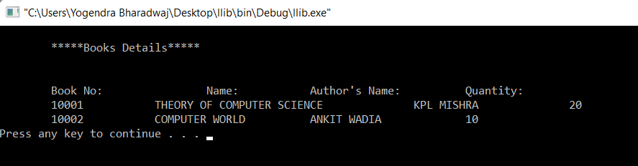

WITH THE HELP OF THIS OPTION WE CAN DISPLAY ALL THE BOOK LIST WHICH IS IN OUR LIBRARY ALONG WITH BOOK NO , NAME OF BOOK , AUTHOR OF BOOK , AND HOW MUCH QUANTITY IS LEFT IN OUR LIBRARY

**8.**

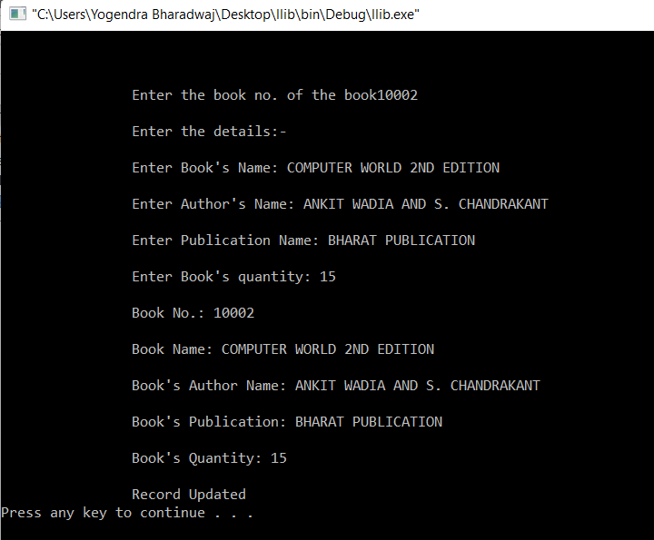

WITH THE HELP OF THIS OPTION, WE CAN DIRECTLY SEARCH THE SPECIFIC BOOK IN OUR LIBRARY WE NO NEED TO SEARCH BOOK IN LONG BOOK LIST HERE WE JUST HAVE TO ENTERED BOOK NO. AND ALL DETAILS ARE DISPLAYED ALONG WITH HOW MUCH BOOK IS LEFT IN OUR LIBRARY.

9. 

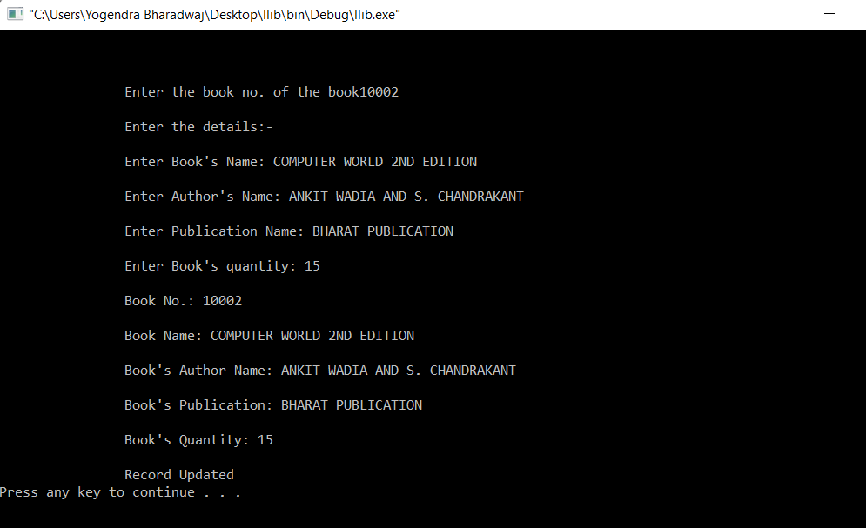

HERE IN THIS OPTION WE CAN MODIFY OR EDIT RECORD OF THE BOOK SUPPOSE OLD VERSION BOOK IS OUTDATED AND COMES IN MARKET WITH SECOND EDITION WITH CO AUTHOR SO IN THAT CASE WE HAVE TO CHANGE BOOK IN LIBRARY ALSO ALONG WITH IN SOFTWARE RECORD ALSO SO WITH THE HELP OF THIS OPTION WE CAN CHANGE THE RECORD OF BOOK ALONG WITH BOOK NAME AUTHOR NAME AND PUBLICATION NAME AFTER THAT THEY SHOW CONFORMATION RECORD UPDATED…

10.

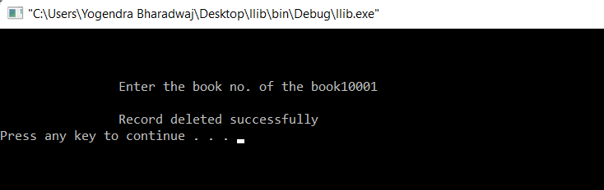

AFTER THE NEW AUTHOR BOOK COMES IN MARKET OLD BOOK IS NOT USED OR NO ISSUE SEEN IS SEEN IN SOME SPECIFIC CASE LIKE IF OLD VERSION BOOK IS COMPLICATED TO UNDERSTAND AND NOT EXPLAIN TOPIC IN DETAIL THAN NO ONE IS ISSUING THAT BOOK IN THAT CASE ALL BOOK IS REMOVE FROM LIBRARY SAME ALSO IN FROM SOFTWARE SO TO DO THIS THIS OPTION IS GIVEN BY JUST ENTERED BOOK NO . AFTER THAT CONFIRMATION IS SEEN RECORD DELETED SUCCESSFULLY.

***NOW WE SEE THE 1ST AND 2ND OPTION IN MAIN SCREEN***

**1.**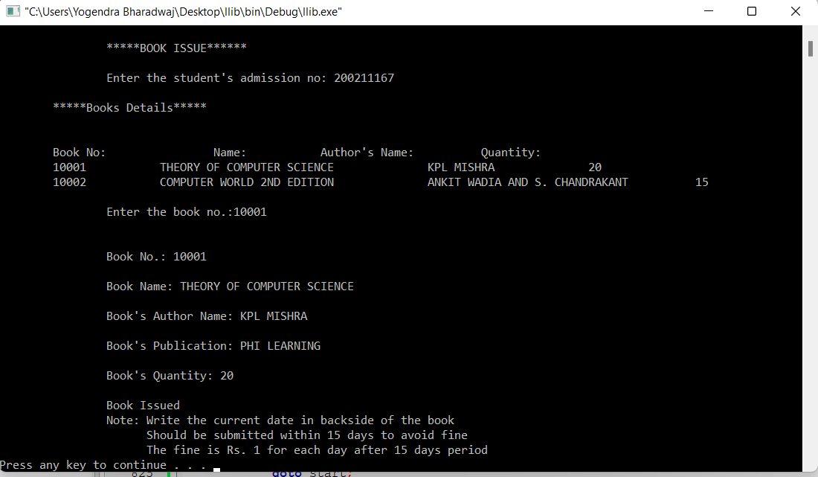

THIS IS THE MAIN OPTION FOR THAT THIS SOFTWARE IS MADE IN THIS OPTION IF WE PRESS 2ND OPTION IN MAIN SCREEN THIS OPTION IS OPEN

ONLY WE HAVE TO ENTER ADMISSION NO OF STUDENT AFTER THAT ALL BOOK LIST SHOW THERE FROM THERE ONLY BASED ON STUDENT CHOICE BOOK NO. IS ENTERED SEEN FROM BOOK OR LIST.

AFTER THAT CONFORMATION IS COME BOOK ISSUED ALONG WITH BOOK NO, BOOK NAME, AUTHOR AND PUBLICATION AND HOW MUCH QUANTITY BOOK IS IN RECORD.

ONE MOST IMPORTANT NOTE IS ALSO COME WITH CONFIRMATION STUDENT HAVE TO SUBMITTED BOOK WITHIN 15 DAYS TO AVOID FINE IF STUDENT COME AFTER 15 DAY TO RETURN BOOK AFTER THAT THEY HAVE TO PAY FINE 1RS. PER DAY AFTER 15 DAYS OF ISSUING DATE OF BOOK

**2.**

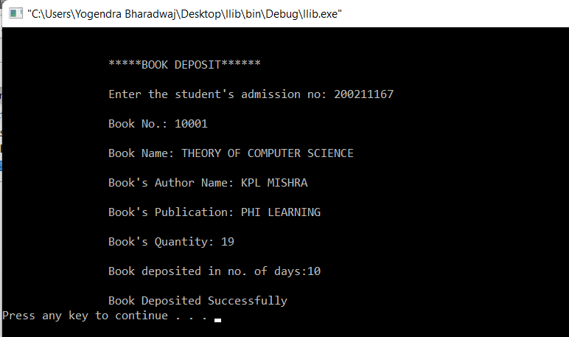

IF ANY STUDENT COME TO DEPOSIT OUR ISSUED BOOK WE CHOOSE 2ND OPTION OF MAIN SCREEN THAT IS DEPOSITE BOOK AFTER THAT ONLY WE HAVE TO ENTERED STUDENT ADMISSION NO. AND IN AFTER HOW MANY DAYS STUDENT COME FOR DEPOSIT BOOK FROM ISSUE DAYS IF THEY COME AFTER 15 DAYS SOFTWARE ALSO SHOW FINE CHARGES 1RS PER DAY AFTER THE 15 DAYS OF DATE OF ISSUE BOOK AND STUDENT HAVE TO PAY FINE TO LIBRARIAN AND THAN BOOK IS DEPOSITED SUCCESSFULLY AND TEND THE RECORD OF STUDENT IS CLEARED……



1. 



“Library Maintenance Software” provides various functions, which increase the productivity of the software. These functions make the system easy to use and convenient. Some of the important features included are as follows:

• Simple & Easy to Use.

• Increased Library Engagement.

• Data Security.

• Fully Customizable.

• No decay of old Records.

**Limitations of Library Management System:**

There are some limitations in the software that are listed as below:

* 1. It is a small-scale system.
  2. Only limited information provided by this system.
  3. Can take the first name of the user only, not the last name.

**CONCLUSION**

The project entitled “Library Maintenance Software” is developed using C++ to computerize the process of library maintenance.

1. 

* <https://www.youtube.com/watch?v=Ekwodc7ixSE&list=PLDLLuBZ1-EtsluXPCiB5b41RAvAQFjVNT>
* <https://www.w3schools.com/cpp/cpp_oop.asp>
* <https://www.w3schools.com/cpp/cpp_classes.asp>
* <https://www.w3schools.com/cpp/cpp_class_methods.asp>